1. The name that characterizes the data set

* Chennai Water Management

1. The organization that generated it

* Thanks to [Chennai Metropolitan Water Supply & Sewage Board](https://chennaimetrowater.tn.gov.in/), the data is obtained from their site.

1. Include an internet link where they can be downloaded online and submit as a spreadsheet along with your corresponding report.

* <https://github.com/gzzcesar/MBD-Data-Mining>

1. Describes the data set. What data does it contain?

* This dataset contains the information about the water availability in the four main reservoirs from the city of Chennai, in India. Data is available on a daily basis over the last 15 years, and the unit of measure is millions of cubic feet (mlcf).

Chennai also known as Madras is the capital of the Indian state of Tamil Nadu. Located on the Coromandel Coast off the Bay of Bengal, it is the biggest cultural, economic and educational centre of south India.

* chennai_reservoir_levels.csv. Talks about the availability of water in the reservoirs.
* chennai_reservoir_rainfall.csv. Talks about water retrieved from rain into the reservoirs

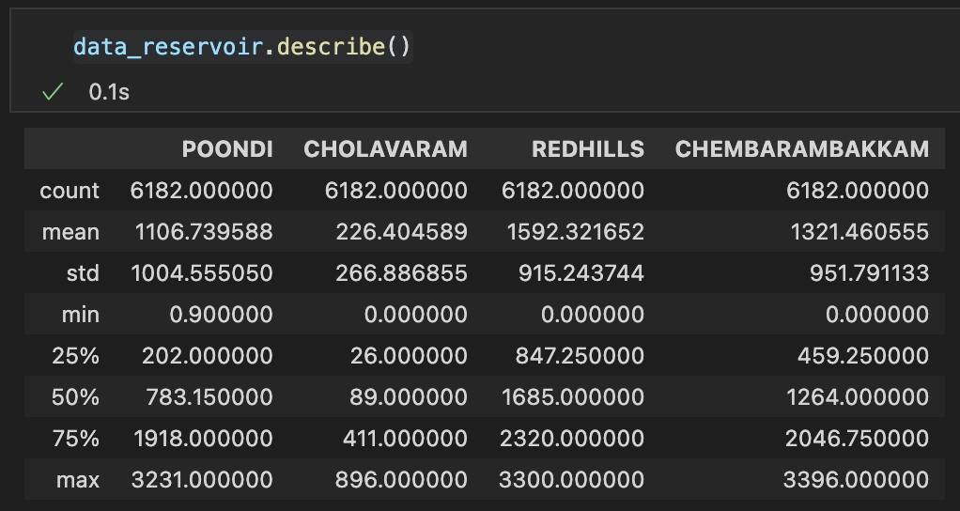 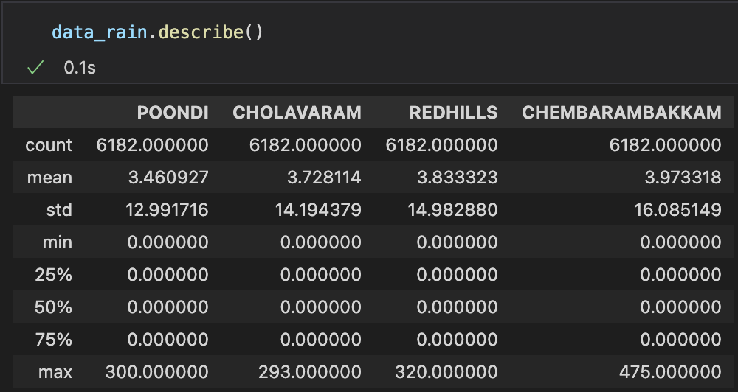

1. What are some of the research questions you could answer with this data? List at least EIGHT (do not answer the questions).
   1. Which months do the reservoirs keep their best and worst levels?
   2. Is the amount of water retrieved from rain really significant to or reliable in seasonality?
   3. How much water from these reservoirs is spent in Chennai?
   4. Is it sustainable the usage of water in Chennai?
   5. Which strategy of usage of the reservoirs should is best for the city? Which reservoirs the city should manage for each reservoir and in which order?
   6. How many more years does the water needs of the city can be satisfied with these resources?
   7. Is every reservoir significant, crucial or efficient? Or the cost of operation could be of better use in some other reservoir or solution?
   8. How is the interaction between reservoirs when operating under minimum critical levels?
2. Which stakeholder (company, sector of society, decentralized body, government, etc.) would be interested in the questions you identified in point 6?

* Indian and Tamil Nadu Government
* Research and Technology funds
* World Health Organization
* United Nations Organization
* Environmental Protection Agency
* Beverage Companies: AB InBev, Heineken, Coca Cola Company, Pepsico, etc.